# Creating a Map in Tableau of New York City Wi-Fi Locations

**Data Set Description:**

<https://data.cityofnewyork.us/City-Government/NYC-Wi-Fi-Hotspot-Locations/yjub-udmw>

**Data Download:**

<https://www.dataplusscience.com/files/Wifi.xlsx>

Open Tableau and select Excel from the opening Tableau screen (or click the logo in the top left corner to get to this screen). Select the Wifi.xlsx spreadsheet that you downloaded. The data import screen will populate with the data. Click the Orange Tab at the bottom marked “Sheet

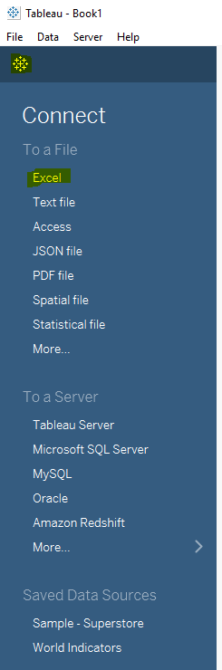 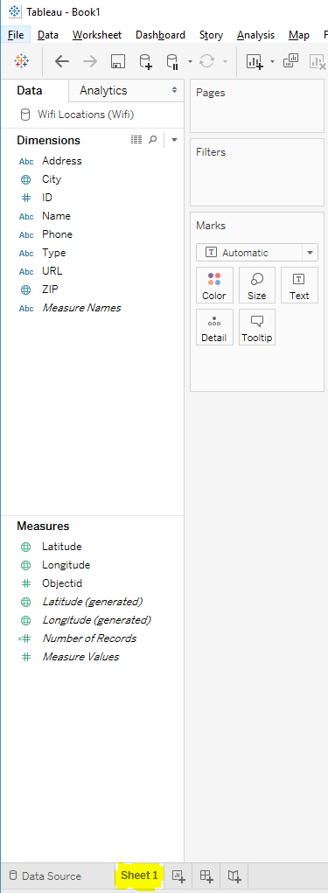

Once the data is loaded follow these step:

**Note - the fields used here are the actual Latitude and Longitude fields that are in the data set, not the “Generated” latitude and longitude that Tableau generates based on geographic fields.**

Move **Longitude** to Columns.

Move **Latitude** to Rows.

Move **ID** to Details on the Marks card.

Move **Type** to Color on the Marks card.

**Adjusting size, color and map layer:**

Select Size on the Marks card and adjust the size to make the circles smaller.

Select Color on the Marks card and then Edit Color (or double click a color on the color legend).

Select Fee-Based and then select a red color.

Select Free and then select a blue color.

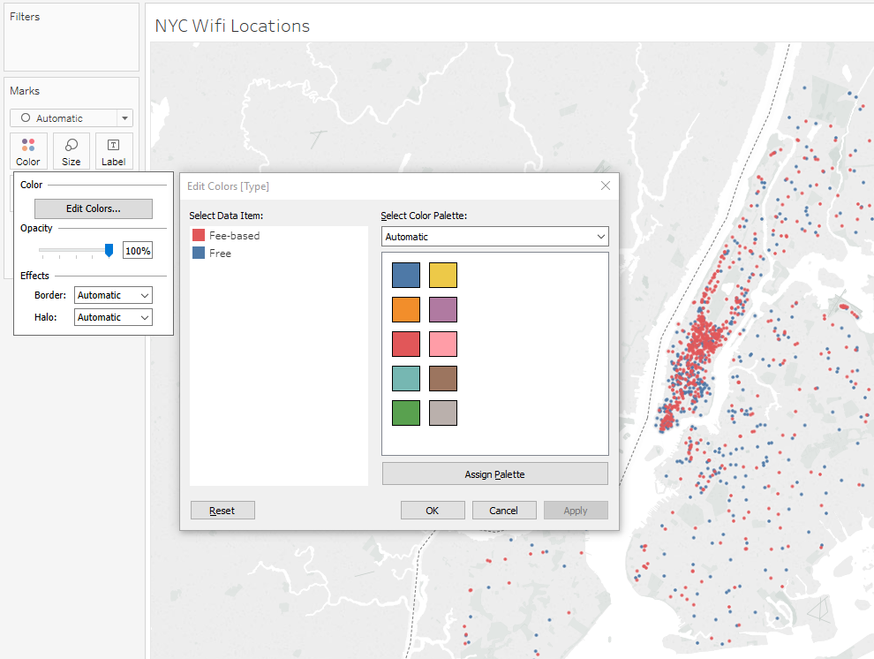

Select Map from the top Menu then select Map Layer.

In the Background select Dark from the Style dropdown.

Uncheck Land Cover from the Map Layers and check Streets and Highways.

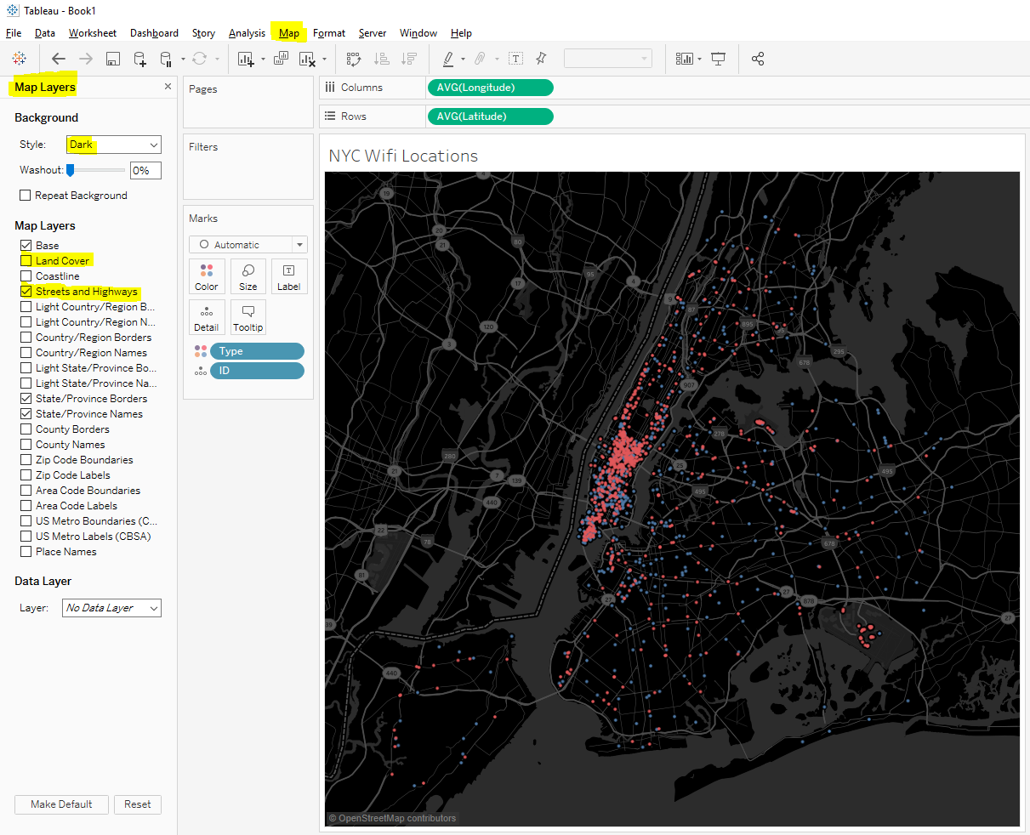

Click the x in the right-hand corner of the Map Layers dialog box.

Move **Name**, **Address** and **Phone** to Tooltips on the Marks card.

Select Tooltip from the Marks card.

Format the tooltip to make it more useful.

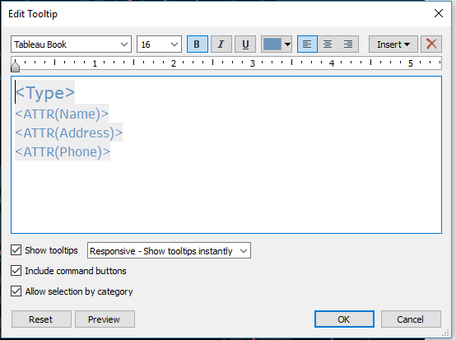 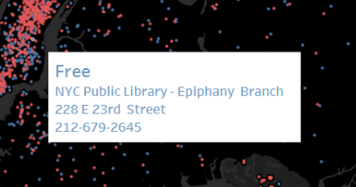

This sheet can now be placed on a new Dashboard and formatted as desired. Adding a Title, a Subtitle with a legend built-in and a filter for the Type (free vs. fee-based). A finished visualization can be downloaded from Tableau Public as an example.

<https://public.tableau.com/views/NYWifi/NYWifi?:embed=y&:display_count=yes&publish=yes>

